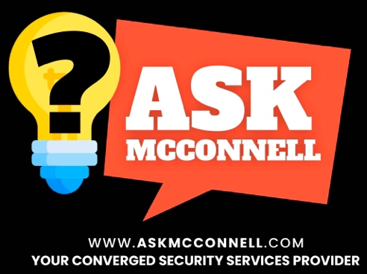

This “VERSUS” document is provided to you as a starting point or maturity checkpoint for existing policies, procedures, and equipment. It is brought to you on behalf of Jim McConnell, Principal Owner, and Ask McConnell, LLC – a converged security services provider. The content is not meant to cover every circumstance, industry, law, regulation, contractual requirement, threat, environment, or risk, but it provides a starting point for any organization. Please consult with your legal counsel and insurance provider about added requirements. If you know of peers that you think would find value in these resources, please have them contact us. These will be updated on our website regularly. We are not legally protecting these documents; we just ask for credit, shout-outs, and referrals if you find them helpful. If you have recommended updates, we are all ears. And if you need Converged Security Consulting and Training, please reach out, we would be honored to serve you and your organization.

Jim McConnell
info@askmcconnell.com
Ask McConnell, LLC
https://askmcconnell.com

Onsite Technology vs. Cloud

Updated: 14 May 2026

This is ONE guy’s perspective that must be weighed against law, insurance, culture, etc.

This decision comes up across every technology category — cameras, access control, alarms, visitor management, and more. The core tradeoff is control vs. convenience. Neither is inherently better. The right answer depends on your budget, your internal IT capability, your tolerance for downtime, and how you think about data privacy and ownership.

 | Onsite Technology | Cloud
Pros | You control the hardware, the data, and the access — it stays on your property.  No ongoing subscription fees after the initial investment.  Core functions do not depend on internet connectivity.  Full control over retention policies, access logs, and data privacy.  With the right system you can still have remote access: administrators can view cameras or manage systems from anywhere. | Lower upfront cost — hardware is often simpler and the vendor manages infrastructure.  Vendor handles software updates, maintenance, and redundancy.  Remote access: administrators can view cameras or manage systems from anywhere.  Scalable without hardware changes — add users, doors, or cameras through software.
Cons | Higher upfront cost for servers, NVRs, and on-premises infrastructure.  You are responsible for maintenance, updates, and eventual hardware replacement.  Local failure (hard drive crash, power surge) can mean total data loss without a backup plan.  Requires IT expertise to maintain properly — often underestimated. | Ongoing subscription cost that grows as you scale.  If your internet connection goes down, you may lose remote access or core functionality.  Your data lives on a third-party server — understand the vendor's privacy, retention, and breach notification policies before signing.  Vendor lock-in is common — switching is costly and disruptive.  The vendor becomes part of your supply chain and requires a strong understanding of contracts with these types of providers.
Also Consider | What is your backup and redundancy plan? A single onsite NVR with no UPS and no offsite backup is a significant and often unrecognized vulnerability.  Who (volunteer? Employee? Supplier?) maintains the system — and what is the plan when that person leaves?  When did you last test your backup and recovery process? | Have you read the vendor's full data privacy policy and terms of service? Who owns your footage?  What happens to your data if you cancel the subscription?  What is the vendor's uptime SLA, and what is your contingency if they go down during an event?  Ask specifically: where is the data physically stored, and under what legal jurisdiction?  Will they use your footage for AI training?

