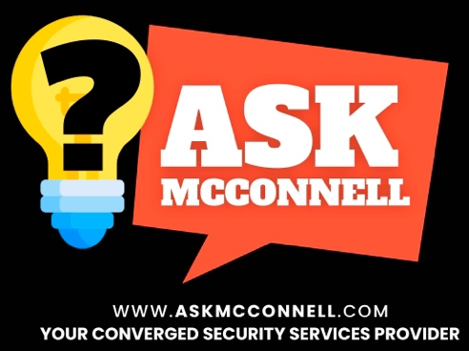

This “VERSUS” document is provided to you as a starting point or maturity checkpoint for existing policies, procedures, and equipment. It is brought to you on behalf of Jim McConnell, Principal Owner, and Ask McConnell, LLC – a converged security services provider. The content is not meant to cover every circumstance, industry, law, regulation, contractual requirement, threat, environment, or risk, but it provides a starting point for any organization. Please consult with your legal counsel and insurance provider about added requirements. If you know of peers that you think would find value in these resources, please have them contact us. These will be updated on our website regularly. We are not legally protecting these documents; we just ask for credit, shout-outs, and referrals if you find them helpful. If you have recommended updates, we are all ears. And if you need Converged Security Consulting and Training, please reach out, we would be honored to serve you and your organization.

Jim McConnell
info@askmcconnell.com
Ask McConnell, LLC
https://askmcconnell.com

Name - Security Team vs. Safety Team

Updated: 14 May 2026

This is ONE guy’s perspective that must be weighed against law, insurance, culture, etc.

This is a common question and the most controversial topic I get……but its almost always limited to what a church calls the team (employees or volunteers or a combination) that perform the function during weekend services, special events, and sometimes during the week services like Youth Night. Remember, security and safety (as I define/scope them) are 24x7x356 responsibility of the church. So the “Team” that covers a service may be different than the “Team” that covers all the other times. DOCUMENT IT.

Reminder of the definitions I use for these two terms for context:

- Security - The Prevention, Detection, and Response to a Crime or a Violation of Organizational Rules
- Safety – The Prevention, Detection, and Response to an Accident (think, spilled water, broken glass, extension cord across the floor, etc)

If you do not have your church leadership, board, team, legal, and insurance agreement on the TERMS, SCOPE, and LIMITS, of these two roles/terms, I might suggest you pause before you continue.

 | Security Team | Safety Team
Pros | It clearly sets the tone, focus for what you are actually doing. Doesn’t mean this team isn’t doing some Safety elements, but if this is what you are doing, call it the correct term | Culture: In some organizations, communities, and faith environments, the word 'Security' carries a negative or militaristic connotation. 'Safety' can feel more welcoming and aligned with a hospitality-first culture.  Volunteer recruitment: Some individuals are more willing to serve on a 'Safety Team' than a 'Security Team,' particularly in church contexts.  If your team is genuinely and primarily performing safety functions as defined above (accident prevention, first aid, fire safety), then 'Safety' is the accurate term.
Cons | If the law has strict laws and regulations on using this term (or doing security), you MUST follow them and govern them 24x7x365. Same with insurance. | If you call yourself safety (under my definition or the law), are you doing all the OSHA requirements including Competent Person rules?  If you call yourself safety (under my definition or the law) and you are doing security functions (under my definition and the law’s definition) there is a HIGH risk that when something “goes sideways”, many people are going to have to answer why is a “Safety Team” doing “Security”
Also Consider | Whatever you call the team, the name must match the legal definition in your state and the scope defined in your insurance policy. Call it what it IS.  Does your leadership team, board, legal counsel, and insurance carrier all agree on the term, scope, and limits? If not, pause before you proceed.  DOCUMENT IT: The name, the scope, the training standard, and who is accountable. | If you call your team 'Safety' but they are performing security functions — responding to threats, removing disruptive individuals, managing access — you are exposed. What does your insurance policy say about that gap?  Many organizations use both: a Safety Team (first aid, fire, accident response) and a Security Team (threat response, access control, behavioral intervention). This is a mature model and worth considering if you have the people to support it.

Different than FUNCTION
Different than Uniform

